**Natural Language Engineering**

**Assignment2 Report**

**(Python Version 3.6)**

**Chao Li – 1802664**

**Yaowei Lv - xxxxxxx**

**Question1**

**a)**

**For S1 we need to add grammar:**

* S -> VP
* P -> 'on'
* N -> 'block' | 'table'

**For S2 we need to add grammar:**

* NP -> PN
* PropN -> 'Bob'
* P -> 'in' | 'along'
* N -> 'river'

**For S3 we need to add grammar:**

* Adj -> 'furry'
* N -> 'dog'
* V -> 'chase'

**b)**

**For S1 we get 2 derivations:**

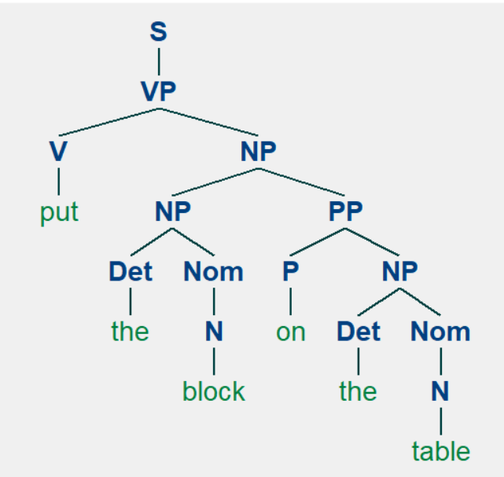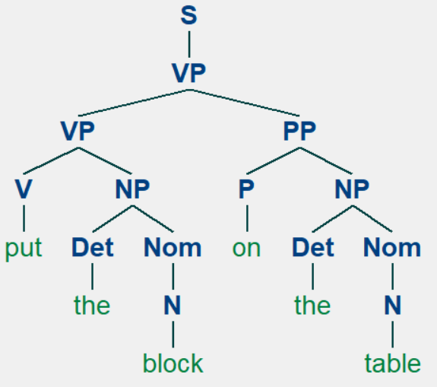

**For S2 we get 5 derivations:**

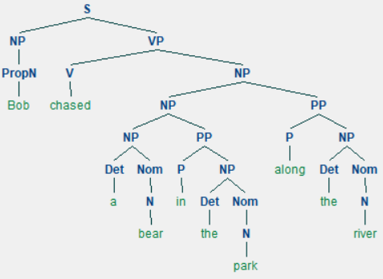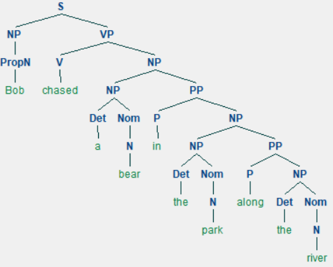 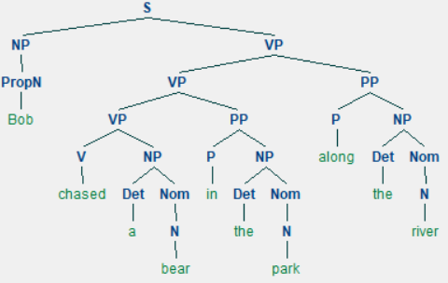 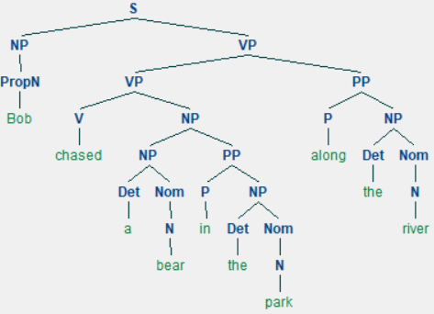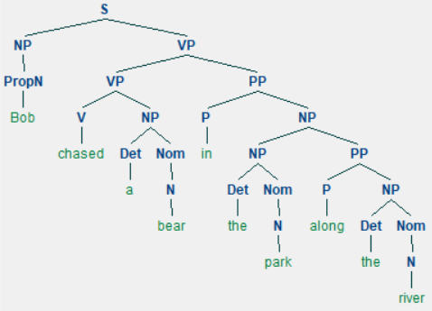

**For S3 we get 1 derivation:**

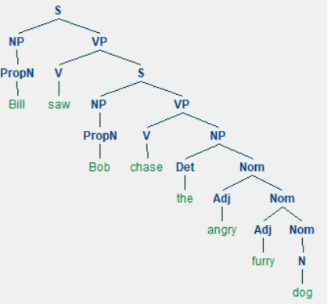

**Question 2**

**a)**

* **These sentences are not correct.**
* **For the first sentence:** 
  1. As the initials of ‘bear’ and ’squirrel’ are not vowel, the determiner should be used ‘a’ instead of ‘an’.
  2. NNS should be used in ‘bear’ and ‘squirrel’. We should use make a generally reference in ‘bear’ and ‘squirrel’.
  3. grammatically correct equivalents: Bears eat squirrels
* **For the second sentence:**
  1. As ‘dogs’ is a NNS, we should use ‘eat’ rather than ‘eats’
  2. grammatically correct equivalents: The dogs eat

**b) We use Bottom-Up Chart Parser and Earley Chart Parsing for S4 and S5**

**Use Bottom-Up Chart Parser for S4:**

|. An . bear . eat . an .squirre.|

|[-------] . . . .| [0:1] 'An'

|. [-------] . . .| [1:2] 'bear'

|. . [-------] . .| [2:3] 'eat'

|. . . [-------] .| [3:4] 'an'

|. . . . [-------]| [4:5] 'squirrel'

|> . . . . .| [0:0] Det -> * 'An'

|[-------] . . . .| [0:1] Det -> 'An' *

|> . . . . .| [0:0] NP -> * Det Nom

|[-------> . . . .| [0:1] NP -> Det * Nom

|. > . . . .| [1:1] N -> * 'bear'

|. [-------] . . .| [1:2] N -> 'bear' *

|. > . . . .| [1:1] Nom -> * N

|. [-------] . . .| [1:2] Nom -> N *

|[---------------] . . .| [0:2] NP -> Det Nom *

|> . . . . .| [0:0] S -> * NP VP

|[---------------> . . .| [0:2] S -> NP * VP

|. . > . . .| [2:2] V -> * 'eat'

|. . [-------] . .| [2:3] V -> 'eat' *

|. . > . . .| [2:2] VP -> * V

|. . > . . .| [2:2] VP -> * V NP

|. . > . . .| [2:2] VP -> * V S

|. . [-------] . .| [2:3] VP -> V *

|. . [-------> . .| [2:3] VP -> V * NP

|. . [-------> . .| [2:3] VP -> V * S

|. . > . . .| [2:2] VP -> * VP PP

|[-----------------------] . .| [0:3] S -> NP VP *

|. . [-------> . .| [2:3] VP -> VP * PP

|. . . > . .| [3:3] Det -> * 'an'

|. . . [-------] .| [3:4] Det -> 'an' *

|. . . > . .| [3:3] NP -> * Det Nom

|. . . [-------> .| [3:4] NP -> Det * Nom

|. . . . > .| [4:4] N -> * 'squirrel'

|. . . . [-------]| [4:5] N -> 'squirrel' *

|. . . . > .| [4:4] Nom -> * N

|. . . . [-------]| [4:5] Nom -> N *

|. . . [---------------]| [3:5] NP -> Det Nom *

|. . . > . .| [3:3] S -> * NP VP

|. . [-----------------------]| [2:5] VP -> V NP *

|. . . [--------------->| [3:5] S -> NP * VP

|[=======================================]| [0:5] S -> NP VP *

|. . [----------------------->| [2:5] VP -> VP * PP

(S

(NP (Det An) (Nom (N bear)))

(VP (V eat) (NP (Det an) (Nom (N squirrel)))))

**Use Bottom-Up Chart Parser for S5:**

|. The . dogs . eats .|

|[-----------] . .| [0:1] 'The'

|. [-----------] .| [1:2] 'dogs'

|. . [-----------]| [2:3] 'eats'

|> . . .| [0:0] Det -> * 'The'

|[-----------] . .| [0:1] Det -> 'The' *

|> . . .| [0:0] NP -> * Det Nom

|[-----------> . .| [0:1] NP -> Det * Nom

|. > . .| [1:1] NNS -> * 'dogs'

|. > . .| [1:1] N -> * 'dogs'

|. [-----------] .| [1:2] NNS -> 'dogs' *

|. [-----------] .| [1:2] N -> 'dogs' *

|. > . .| [1:1] Nom -> * N

|. [-----------] .| [1:2] Nom -> N *

|[-----------------------] .| [0:2] NP -> Det Nom *

|> . . .| [0:0] S -> * NP VP

|[-----------------------> .| [0:2] S -> NP * VP

|. > . .| [1:1] NP -> * NNS

|. [-----------] .| [1:2] NP -> NNS *

|. > . .| [1:1] S -> * NP VP

|. [-----------> .| [1:2] S -> NP * VP

|. . > .| [2:2] V -> * 'eats'

|. . [-----------]| [2:3] V -> 'eats' *

|. . > .| [2:2] VP -> * V

|. . > .| [2:2] VP -> * V NP

|. . > .| [2:2] VP -> * V S

|. . [-----------]| [2:3] VP -> V *

|. . [----------->| [2:3] VP -> V * NP

|. . [----------->| [2:3] VP -> V * S

|. . > .| [2:2] VP -> * VP PP

|[===================================]| [0:3] S -> NP VP *

|. [-----------------------]| [1:3] S -> NP VP *

|. . [----------->| [2:3] VP -> VP * PP

(S (NP (Det The) (Nom (N dogs))) (VP (V eats)))

**Use Earley Chart Parser for S4:**

|. An . bear . eat . an .squirre.|

|[-------] . . . .| [0:1] 'An'

|. [-------] . . .| [1:2] 'bear'

|. . [-------] . .| [2:3] 'eat'

|. . . [-------] .| [3:4] 'an'

|. . . . [-------]| [4:5] 'squirrel'

|> . . . . .| [0:0] S -> * NP VP

|> . . . . .| [0:0] NP -> * Det Nom

|> . . . . .| [0:0] NP -> * PropN

|> . . . . .| [0:0] NP -> * NNS

|> . . . . .| [0:0] Det -> * 'An'

|[-------] . . . .| [0:1] Det -> 'An' *

|[-------> . . . .| [0:1] NP -> Det * Nom

|. > . . . .| [1:1] Nom -> * N

|. > . . . .| [1:1] N -> * 'bear'

|. [-------] . . .| [1:2] N -> 'bear' *

|. [-------] . . .| [1:2] Nom -> N *

|[---------------] . . .| [0:2] NP -> Det Nom *

|[---------------> . . .| [0:2] S -> NP * VP

|. . > . . .| [2:2] VP -> * VP PP

|. . > . . .| [2:2] VP -> * V

|. . > . . .| [2:2] VP -> * V NP

|. . > . . .| [2:2] VP -> * V S

|. . > . . .| [2:2] V -> * 'eat'

|. . [-------] . .| [2:3] V -> 'eat' *

|. . [-------] . .| [2:3] VP -> V *

|. . [-------> . .| [2:3] VP -> V * NP

|. . [-------> . .| [2:3] VP -> V * S

|. . . > . .| [3:3] S -> * NP VP

|. . . > . .| [3:3] NP -> * Det Nom

|. . . > . .| [3:3] NP -> * PropN

|. . . > . .| [3:3] NP -> * NNS

|. . . > . .| [3:3] Det -> * 'an'

|[-----------------------] . .| [0:3] S -> NP VP *

|. . [-------> . .| [2:3] VP -> VP * PP

|. . . [-------] .| [3:4] Det -> 'an' *

|. . . [-------> .| [3:4] NP -> Det * Nom

|. . . . > .| [4:4] Nom -> * N

|. . . . > .| [4:4] N -> * 'squirrel'

|. . . . [-------]| [4:5] N -> 'squirrel' *

|. . . . [-------]| [4:5] Nom -> N *

|. . . [---------------]| [3:5] NP -> Det Nom *

|. . [-----------------------]| [2:5] VP -> V NP *

|. . . [--------------->| [3:5] S -> NP * VP

|. . . . . >| [5:5] VP -> * VP PP

|. . . . . >| [5:5] VP -> * V

|. . . . . >| [5:5] VP -> * V NP

|. . . . . >| [5:5] VP -> * V S

|[=======================================]| [0:5] S -> NP VP *

|. . [----------------------->| [2:5] VP -> VP * PP

(S

(NP (Det An) (Nom (N bear)))

(VP (V eat) (NP (Det an) (Nom (N squirrel)))))

**Use Earley Chart Parser for S5:**

|. The . dogs . eats .|

|[-----------] . .| [0:1] 'The'

|. [-----------] .| [1:2] 'dogs'

|. . [-----------]| [2:3] 'eats'

|> . . .| [0:0] S -> * NP VP

|> . . .| [0:0] NP -> * Det Nom

|> . . .| [0:0] NP -> * PropN

|> . . .| [0:0] NP -> * NNS

|> . . .| [0:0] Det -> * 'The'

|[-----------] . .| [0:1] Det -> 'The' *

|[-----------> . .| [0:1] NP -> Det * Nom

|. > . .| [1:1] Nom -> * N

|. > . .| [1:1] N -> * 'dogs'

|. [-----------] .| [1:2] N -> 'dogs' *

|. [-----------] .| [1:2] Nom -> N *

|[-----------------------] .| [0:2] NP -> Det Nom *

|[-----------------------> .| [0:2] S -> NP * VP

|. . > .| [2:2] VP -> * VP PP

|. . > .| [2:2] VP -> * V

|. . > .| [2:2] VP -> * V NP

|. . > .| [2:2] VP -> * V S

|. . > .| [2:2] V -> * 'eats'

|. . [-----------]| [2:3] V -> 'eats' *

|. . [-----------]| [2:3] VP -> V *

|. . [----------->| [2:3] VP -> V * NP

|. . [----------->| [2:3] VP -> V * S

|. . . >| [3:3] S -> * NP VP

|. . . >| [3:3] NP -> * Det Nom

|. . . >| [3:3] NP -> * PropN

|. . . >| [3:3] NP -> * NNS

|[===================================]| [0:3] S -> NP VP *

|. . [----------->| [2:3] VP -> VP * PP

(S (NP (Det The) (Nom (N dogs))) (VP (V eats)))

**Q: Explain why the parsers are correct or incorrect:**

A: The parsers are incorrect, because the grammars are too simple. Although they can grammatically recognize the sentences, they fail to parser the sentence by correct singular-plural pair, tense and vowel.

**c)**

**Correct sentence1: A boy wins a game**

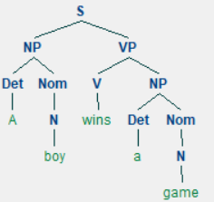

**Correct sentence 2: The girl is sleeping**

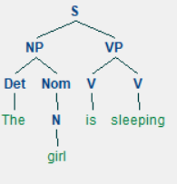

**Incorrect sentence 1: An boy win an game**

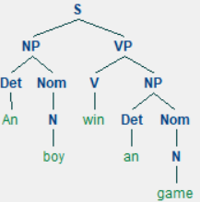

**Incorrect sentence2: A girls sleep**

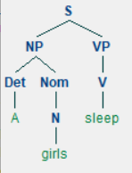

**Q: How would you have to change this grammar to prevent these sentences from being parsed?**

**A: For the incorrect sentence, we can make the grammar more complex and more detailed. For example, instead of Det -> ‘a’ | ‘an’, we can turn them into Detnonvowel -> 'a', Detnvowel -> ‘an’. In this case, if the first letter of a noun is vowel, only ‘an’ can connect with to form a grammar. Similarly, we can make grammar of tense or pronoun more detailed. The following are the revised sentence for the incorrect sentence parsed by more detailed grammar:**

**Incorrect sentence ‘A girls sleep’ after revised:**

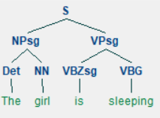

**Incorrect sentence ‘An boy win an game’ after revised:**

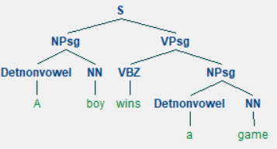

**Question3**

**a) Both S6 and S7 have more than 1 interpretations.**

**For S6, we get 5 derivations:**

**Interpretation1:** He is in the restaurant, and eats pasta. Anchovies are in the pasta

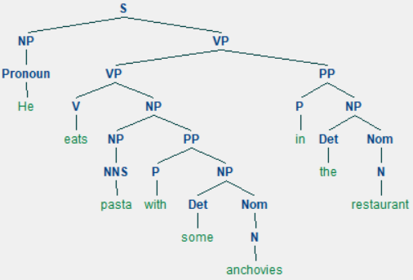

**Interpretation1**

**Interpretation2:** He isin the restaurant, and eats past, and some anchovies. (Anchovies are not in the pasta)

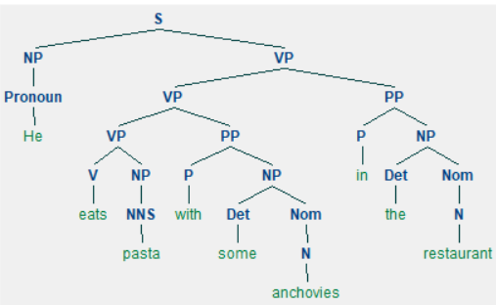

**Interpretation2**

**Interpretation3:** He eats pasta. Anchovies are in the pasta. And anchovies are from the restaurant.

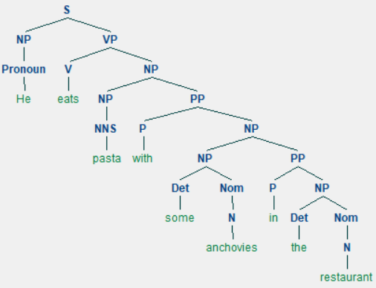

**Interpretation3**

**Interpretation4:** He eats pasta. Anchovies are in the pasta. The pasta is from the restaurant.

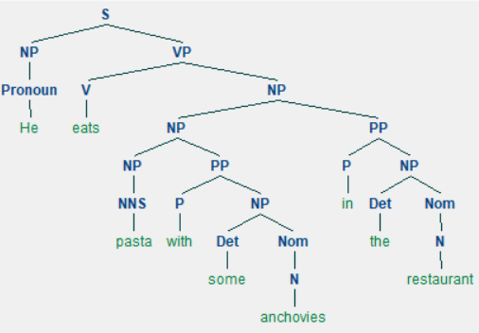

**Interpretation4**

**Interpretation5: He eats pasta and some anchovies (Anchovies are not in pasta). Anchovies are from the restaurant.**

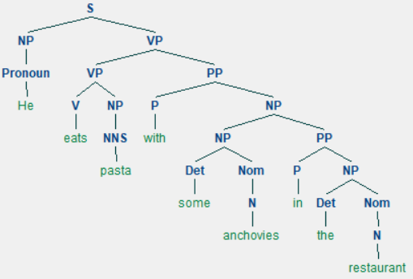

**Interpretation5**

**For S7, we get 5 derivations:**

**Interpretation1: He eats pasta. A fork is in pasta. Pasta is from the restaurant.**

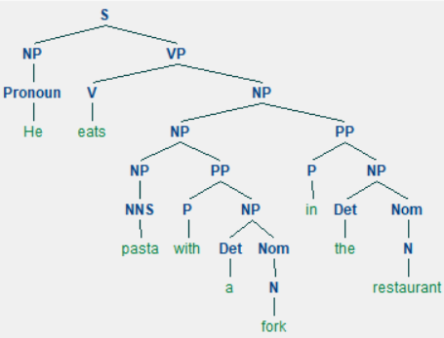

**Interpretation1**

**Interpretation2: He eats pasta. A fork is in pasta. And the fork is from the restaurant.**

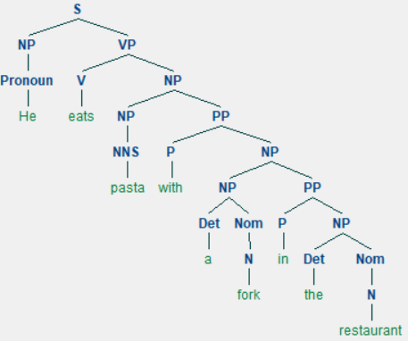

**Interpretation2**

**Interpretation3: He uses a fork to eat pasta and he is in the restaurant**

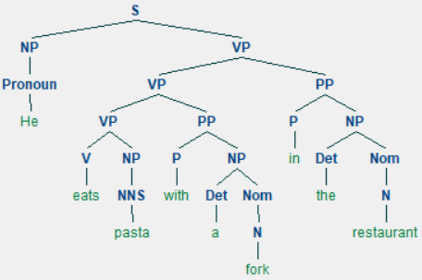

**Interpretation3**

**Interpretation4: He eats pasta, and he is in the restaurant. A fork is in pasta.**

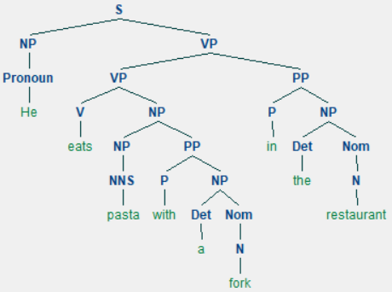

**Interpretation4**

**Interpretation5: He use a fork to eat pasta. The fork is from the restaurant.**

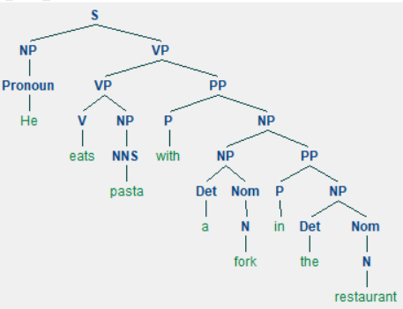

**Interpretation5**

**b)**

**S6: He eats pasta with some anchovies in the restaurant - Shift-reduce:**

Parsing 'He eats pasta with some anchovies in the restaurant'

[ * He eats pasta with some anchovies in the restaurant]

S [ 'He' * eats pasta with some anchovies in the restaurant]

R [ Pronoun * eats pasta with some anchovies in the restaurant]

S [ Pronoun 'eats' * pasta with some anchovies in the restaurant]

R [ Pronoun V * pasta with some anchovies in the restaurant]

S [ Pronoun V 'pasta' * with some anchovies in the restaurant]

R [ Pronoun V NNS * with some anchovies in the restaurant]

S [ Pronoun V NNS 'with' * some anchovies in the restaurant]

R [ Pronoun V NNS P * some anchovies in the restaurant]

S [ Pronoun V NNS P 'some' * anchovies in the restaurant]

R [ Pronoun V NNS P Det * anchovies in the restaurant]

S [ Pronoun V NNS P Det 'anchovies' * in the restaurant]

R [ Pronoun V NNS P Det N * in the restaurant]

R [ Pronoun V NNS P NP * in the restaurant]

R [ Pronoun V NNS PP * in the restaurant]

R [ Pronoun V NP * in the restaurant]

R [ Pronoun VP * in the restaurant]

R [ S * in the restaurant]

S [ S 'in' * the restaurant]

R [ S P * the restaurant]

S [ S P 'the' * restaurant]

R [ S P Det * restaurant]

S [ S P Det 'restaurant' * ]

R [ S P Det N * ]

R [ S P NP * ]

R [ S PP * ]

R [ S * ]

(S

(S

(Pronoun He)

(VP

(V eats)

(NP (NNS pasta) (PP (P with) (NP (Det some) (N anchovies))))))

(PP (P in) (NP (Det the) (N restaurant))))

**S6: He eats pasta with some anchovies in the restaurant – Earley Chart Parser:**

|. He .eats.past.with.some.anch. in .the .rest.|

|[----] . . . . . . . .| [0:1] 'He'

|. [----] . . . . . . .| [1:2] 'eats'

|. . [----] . . . . . .| [2:3] 'pasta'

|. . . [----] . . . . .| [3:4] 'with'

|. . . . [----] . . . .| [4:5] 'some'

|. . . . . [----] . . .| [5:6] 'anchovies'

|. . . . . . [----] . .| [6:7] 'in'

|. . . . . . . [----] .| [7:8] 'the'

|. . . . . . . . [----]| [8:9] 'restaurant'

|> . . . . . . . . .| [0:0] S -> * NP VP

|> . . . . . . . . .| [0:0] NP -> * Det Nom

|> . . . . . . . . .| [0:0] NP -> * NP PP

|> . . . . . . . . .| [0:0] NP -> * NNS

|> . . . . . . . . .| [0:0] NP -> * Pronoun

|> . . . . . . . . .| [0:0] Pronoun -> * 'He'

|[----] . . . . . . . .| [0:1] Pronoun -> 'He' *

|[----] . . . . . . . .| [0:1] NP -> Pronoun *

|[----> . . . . . . . .| [0:1] S -> NP * VP

|[----> . . . . . . . .| [0:1] NP -> NP * PP

|. > . . . . . . . .| [1:1] PP -> * P NP

|. > . . . . . . . .| [1:1] VP -> * VP PP

|. > . . . . . . . .| [1:1] VP -> * V NP

|. > . . . . . . . .| [1:1] VP -> * V S

|. > . . . . . . . .| [1:1] V -> * 'eats'

|. [----] . . . . . . .| [1:2] V -> 'eats' *

|. [----> . . . . . . .| [1:2] VP -> V * NP

|. [----> . . . . . . .| [1:2] VP -> V * S

|. . > . . . . . . .| [2:2] S -> * NP VP

|. . > . . . . . . .| [2:2] NP -> * Det Nom

|. . > . . . . . . .| [2:2] NP -> * NP PP

|. . > . . . . . . .| [2:2] NP -> * NNS

|. . > . . . . . . .| [2:2] NP -> * Pronoun

|. . > . . . . . . .| [2:2] NNS -> * 'pasta'

|. . [----] . . . . . .| [2:3] NNS -> 'pasta' *

|. . [----] . . . . . .| [2:3] NP -> NNS *

|. [---------] . . . . . .| [1:3] VP -> V NP *

|. . [----> . . . . . .| [2:3] S -> NP * VP

|. . [----> . . . . . .| [2:3] NP -> NP * PP

|. . . > . . . . . .| [3:3] PP -> * P NP

|. . . > . . . . . .| [3:3] P -> * 'with'

|. . . > . . . . . .| [3:3] VP -> * VP PP

|. . . > . . . . . .| [3:3] VP -> * V NP

|. . . > . . . . . .| [3:3] VP -> * V S

|[--------------] . . . . . .| [0:3] S -> NP VP *

|. [---------> . . . . . .| [1:3] VP -> VP * PP

|. . . [----] . . . . .| [3:4] P -> 'with' *

|. . . [----> . . . . .| [3:4] PP -> P * NP

|. . . . > . . . . .| [4:4] NP -> * Det Nom

|. . . . > . . . . .| [4:4] NP -> * NP PP

|. . . . > . . . . .| [4:4] NP -> * NNS

|. . . . > . . . . .| [4:4] NP -> * Pronoun

|. . . . > . . . . .| [4:4] Det -> * 'some'

|. . . . [----] . . . .| [4:5] Det -> 'some' *

|. . . . [----> . . . .| [4:5] NP -> Det * Nom

|. . . . . > . . . .| [5:5] Nom -> * N

|. . . . . > . . . .| [5:5] N -> * 'anchovies'

|. . . . . [----] . . .| [5:6] N -> 'anchovies' *

|. . . . . [----] . . .| [5:6] Nom -> N *

|. . . . [---------] . . .| [4:6] NP -> Det Nom *

|. . . [--------------] . . .| [3:6] PP -> P NP *

|. . . . [---------> . . .| [4:6] NP -> NP * PP

|. . . . . . > . . .| [6:6] PP -> * P NP

|. . . . . . > . . .| [6:6] P -> * 'in'

|. . [-------------------] . . .| [2:6] NP -> NP PP *

|. [------------------------] . . .| [1:6] VP -> VP PP *

|[-----------------------------] . . .| [0:6] S -> NP VP *

|. [------------------------> . . .| [1:6] VP -> VP * PP

|. [------------------------] . . .| [1:6] VP -> V NP *

|. . [-------------------> . . .| [2:6] S -> NP * VP

|. . [-------------------> . . .| [2:6] NP -> NP * PP

|. . . . . . > . . .| [6:6] VP -> * VP PP

|. . . . . . > . . .| [6:6] VP -> * V NP

|. . . . . . > . . .| [6:6] VP -> * V S

|[-----------------------------] . . .| [0:6] S -> NP VP *

|. [------------------------> . . .| [1:6] VP -> VP * PP

|. . . . . . [----] . .| [6:7] P -> 'in' *

|. . . . . . [----> . .| [6:7] PP -> P * NP

|. . . . . . . > . .| [7:7] NP -> * Det Nom

|. . . . . . . > . .| [7:7] NP -> * NP PP

|. . . . . . . > . .| [7:7] NP -> * NNS

|. . . . . . . > . .| [7:7] NP -> * Pronoun

|. . . . . . . > . .| [7:7] Det -> * 'the'

|. . . . . . . [----] .| [7:8] Det -> 'the' *

|. . . . . . . [----> .| [7:8] NP -> Det * Nom

|. . . . . . . . > .| [8:8] Nom -> * N

|. . . . . . . . > .| [8:8] N -> * 'restaurant'

|. . . . . . . . [----]| [8:9] N -> 'restaurant' *

|. . . . . . . . [----]| [8:9] Nom -> N *

|. . . . . . . [---------]| [7:9] NP -> Det Nom *

|. . . . . . [--------------]| [6:9] PP -> P NP *

|. . . . . . . [--------->| [7:9] NP -> NP * PP

|. . . . . . . . . >| [9:9] PP -> * P NP

|. . . . [------------------------]| [4:9] NP -> NP PP *

|. [---------------------------------------]| [1:9] VP -> VP PP *

|. . [----------------------------------]| [2:9] NP -> NP PP *

|. [---------------------------------------]| [1:9] VP -> V NP *

|. . [---------------------------------->| [2:9] S -> NP * VP

|. . [---------------------------------->| [2:9] NP -> NP * PP

|. . . . . . . . . >| [9:9] VP -> * VP PP

|. . . . . . . . . >| [9:9] VP -> * V NP

|. . . . . . . . . >| [9:9] VP -> * V S

|[============================================]| [0:9] S -> NP VP *

|. [--------------------------------------->| [1:9] VP -> VP * PP

|[============================================]| [0:9] S -> NP VP *

|. [--------------------------------------->| [1:9] VP -> VP * PP

|. . . [-----------------------------]| [3:9] PP -> P NP *

|. . . . [------------------------>| [4:9] NP -> NP * PP

|. . [----------------------------------]| [2:9] NP -> NP PP *

|. [---------------------------------------]| [1:9] VP -> VP PP *

(S

(NP (Pronoun He))

(VP

(V eats)

(NP

(NP

(NP (NNS pasta))

(PP (P with) (NP (Det some) (Nom (N anchovies)))))

(PP (P in) (NP (Det the) (Nom (N restaurant)))))))

(S

(NP (Pronoun He))

(VP

(V eats)

(NP

(NP (NNS pasta))

(PP

(P with)

(NP

(NP (Det some) (Nom (N anchovies)))

(PP (P in) (NP (Det the) (Nom (N restaurant)))))))))

(S

(NP (Pronoun He))

(VP

(VP

(VP (V eats) (NP (NNS pasta)))

(PP (P with) (NP (Det some) (Nom (N anchovies)))))

(PP (P in) (NP (Det the) (Nom (N restaurant))))))

(S

(NP (Pronoun He))

(VP

(VP

(V eats)

(NP

(NP (NNS pasta))

(PP (P with) (NP (Det some) (Nom (N anchovies))))))

(PP (P in) (NP (Det the) (Nom (N restaurant))))))

(S

(NP (Pronoun He))

(VP

(VP (V eats) (NP (NNS pasta)))

(PP

(P with)

(NP

(NP (Det some) (Nom (N anchovies)))

(PP (P in) (NP (Det the) (Nom (N restaurant))))))))

**S7: He eats pasta with a fork in the restaurant – Shift Reduce:**

Parsing 'He eats pasta with a fork in the restaurant'

[ * He eats pasta with a fork in the restaurant]

S [ 'He' * eats pasta with a fork in the restaurant]

R [ Pronoun * eats pasta with a fork in the restaurant]

S [ Pronoun 'eats' * pasta with a fork in the restaurant]

R [ Pronoun V * pasta with a fork in the restaurant]

S [ Pronoun V 'pasta' * with a fork in the restaurant]

R [ Pronoun V NNS * with a fork in the restaurant]

R [ Pronoun VP * with a fork in the restaurant]

R [ S * with a fork in the restaurant]

S [ S 'with' * a fork in the restaurant]

R [ S P * a fork in the restaurant]

S [ S P 'a' * fork in the restaurant]

R [ S P Det * fork in the restaurant]

S [ S P Det 'fork' * in the restaurant]

R [ S P Det N * in the restaurant]

R [ S P NP * in the restaurant]

R [ S PP * in the restaurant]

R [ S * in the restaurant]

S [ S 'in' * the restaurant]

R [ S P * the restaurant]

S [ S P 'the' * restaurant]

R [ S P Det * restaurant]

S [ S P Det 'restaurant' * ]

R [ S P Det N * ]

R [ S P NP * ]

R [ S PP * ]

R [ S * ]

(S

(S

(S (Pronoun He) (VP (V eats) (NNS pasta)))

(PP (P with) (NP (Det a) (N fork))))

(PP (P in) (NP (Det the) (N restaurant))))

**S7: He eats pasta with a fork in the restaurant – Earley Chart Parser:**

|. He .eats.past.with. a .fork. in .the .rest.|

|[----] . . . . . . . .| [0:1] 'He'

|. [----] . . . . . . .| [1:2] 'eats'

|. . [----] . . . . . .| [2:3] 'pasta'

|. . . [----] . . . . .| [3:4] 'with'

|. . . . [----] . . . .| [4:5] 'a'

|. . . . . [----] . . .| [5:6] 'fork'

|. . . . . . [----] . .| [6:7] 'in'

|. . . . . . . [----] .| [7:8] 'the'

|. . . . . . . . [----]| [8:9] 'restaurant'

|> . . . . . . . . .| [0:0] S -> * NP VP

|> . . . . . . . . .| [0:0] NP -> * Det Nom

|> . . . . . . . . .| [0:0] NP -> * NP PP

|> . . . . . . . . .| [0:0] NP -> * NNS

|> . . . . . . . . .| [0:0] NP -> * Pronoun

|> . . . . . . . . .| [0:0] Pronoun -> * 'He'

|[----] . . . . . . . .| [0:1] Pronoun -> 'He' *

|[----] . . . . . . . .| [0:1] NP -> Pronoun *

|[----> . . . . . . . .| [0:1] S -> NP * VP

|[----> . . . . . . . .| [0:1] NP -> NP * PP

|. > . . . . . . . .| [1:1] PP -> * P NP

|. > . . . . . . . .| [1:1] VP -> * VP PP

|. > . . . . . . . .| [1:1] VP -> * V NP

|. > . . . . . . . .| [1:1] VP -> * V S

|. > . . . . . . . .| [1:1] V -> * 'eats'

|. [----] . . . . . . .| [1:2] V -> 'eats' *

|. [----> . . . . . . .| [1:2] VP -> V * NP

|. [----> . . . . . . .| [1:2] VP -> V * S

|. . > . . . . . . .| [2:2] S -> * NP VP

|. . > . . . . . . .| [2:2] NP -> * Det Nom

|. . > . . . . . . .| [2:2] NP -> * NP PP

|. . > . . . . . . .| [2:2] NP -> * NNS

|. . > . . . . . . .| [2:2] NP -> * Pronoun

|. . > . . . . . . .| [2:2] NNS -> * 'pasta'

|. . [----] . . . . . .| [2:3] NNS -> 'pasta' *

|. . [----] . . . . . .| [2:3] NP -> NNS *

|. [---------] . . . . . .| [1:3] VP -> V NP *

|. . [----> . . . . . .| [2:3] S -> NP * VP

|. . [----> . . . . . .| [2:3] NP -> NP * PP

|. . . > . . . . . .| [3:3] PP -> * P NP

|. . . > . . . . . .| [3:3] P -> * 'with'

|. . . > . . . . . .| [3:3] VP -> * VP PP

|. . . > . . . . . .| [3:3] VP -> * V NP

|. . . > . . . . . .| [3:3] VP -> * V S

|[--------------] . . . . . .| [0:3] S -> NP VP *

|. [---------> . . . . . .| [1:3] VP -> VP * PP

|. . . [----] . . . . .| [3:4] P -> 'with' *

|. . . [----> . . . . .| [3:4] PP -> P * NP

|. . . . > . . . . .| [4:4] NP -> * Det Nom

|. . . . > . . . . .| [4:4] NP -> * NP PP

|. . . . > . . . . .| [4:4] NP -> * NNS

|. . . . > . . . . .| [4:4] NP -> * Pronoun

|. . . . > . . . . .| [4:4] Det -> * 'a'

|. . . . [----] . . . .| [4:5] Det -> 'a' *

|. . . . [----> . . . .| [4:5] NP -> Det * Nom

|. . . . . > . . . .| [5:5] Nom -> * N

|. . . . . > . . . .| [5:5] N -> * 'fork'

|. . . . . [----] . . .| [5:6] N -> 'fork' *

|. . . . . [----] . . .| [5:6] Nom -> N *

|. . . . [---------] . . .| [4:6] NP -> Det Nom *

|. . . [--------------] . . .| [3:6] PP -> P NP *

|. . . . [---------> . . .| [4:6] NP -> NP * PP

|. . . . . . > . . .| [6:6] PP -> * P NP

|. . . . . . > . . .| [6:6] P -> * 'in'

|. . [-------------------] . . .| [2:6] NP -> NP PP *

|. [------------------------] . . .| [1:6] VP -> VP PP *

|[-----------------------------] . . .| [0:6] S -> NP VP *

|. [------------------------> . . .| [1:6] VP -> VP * PP

|. [------------------------] . . .| [1:6] VP -> V NP *

|. . [-------------------> . . .| [2:6] S -> NP * VP

|. . [-------------------> . . .| [2:6] NP -> NP * PP

|. . . . . . > . . .| [6:6] VP -> * VP PP

|. . . . . . > . . .| [6:6] VP -> * V NP

|. . . . . . > . . .| [6:6] VP -> * V S

|[-----------------------------] . . .| [0:6] S -> NP VP *

|. [------------------------> . . .| [1:6] VP -> VP * PP

|. . . . . . [----] . .| [6:7] P -> 'in' *

|. . . . . . [----> . .| [6:7] PP -> P * NP

|. . . . . . . > . .| [7:7] NP -> * Det Nom

|. . . . . . . > . .| [7:7] NP -> * NP PP

|. . . . . . . > . .| [7:7] NP -> * NNS

|. . . . . . . > . .| [7:7] NP -> * Pronoun

|. . . . . . . > . .| [7:7] Det -> * 'the'

|. . . . . . . [----] .| [7:8] Det -> 'the' *

|. . . . . . . [----> .| [7:8] NP -> Det * Nom

|. . . . . . . . > .| [8:8] Nom -> * N

|. . . . . . . . > .| [8:8] N -> * 'restaurant'

|. . . . . . . . [----]| [8:9] N -> 'restaurant' *

|. . . . . . . . [----]| [8:9] Nom -> N *

|. . . . . . . [---------]| [7:9] NP -> Det Nom *

|. . . . . . [--------------]| [6:9] PP -> P NP *

|. . . . . . . [--------->| [7:9] NP -> NP * PP

|. . . . . . . . . >| [9:9] PP -> * P NP

|. . . . [------------------------]| [4:9] NP -> NP PP *

|. [---------------------------------------]| [1:9] VP -> VP PP *

|. . [----------------------------------]| [2:9] NP -> NP PP *

|. [---------------------------------------]| [1:9] VP -> V NP *

|. . [---------------------------------->| [2:9] S -> NP * VP

|. . [---------------------------------->| [2:9] NP -> NP * PP

|. . . . . . . . . >| [9:9] VP -> * VP PP

|. . . . . . . . . >| [9:9] VP -> * V NP

|. . . . . . . . . >| [9:9] VP -> * V S

|[============================================]| [0:9] S -> NP VP *

|. [--------------------------------------->| [1:9] VP -> VP * PP

|[============================================]| [0:9] S -> NP VP *

|. [--------------------------------------->| [1:9] VP -> VP * PP

|. . . [-----------------------------]| [3:9] PP -> P NP *

|. . . . [------------------------>| [4:9] NP -> NP * PP

|. . [----------------------------------]| [2:9] NP -> NP PP *

|. [---------------------------------------]| [1:9] VP -> VP PP *

(S

(NP (Pronoun He))

(VP

(V eats)

(NP

(NP (NP (NNS pasta)) (PP (P with) (NP (Det a) (Nom (N fork)))))

(PP (P in) (NP (Det the) (Nom (N restaurant)))))))

(S

(NP (Pronoun He))

(VP

(V eats)

(NP

(NP (NNS pasta))

(PP

(P with)

(NP

(NP (Det a) (Nom (N fork)))

(PP (P in) (NP (Det the) (Nom (N restaurant)))))))))

(S

(NP (Pronoun He))

(VP

(VP

(VP (V eats) (NP (NNS pasta)))

(PP (P with) (NP (Det a) (Nom (N fork)))))

(PP (P in) (NP (Det the) (Nom (N restaurant))))))

(S

(NP (Pronoun He))

(VP

(VP

(V eats)

(NP (NP (NNS pasta)) (PP (P with) (NP (Det a) (Nom (N fork))))))

(PP (P in) (NP (Det the) (Nom (N restaurant))))))

(S

(NP (Pronoun He))

(VP

(VP (V eats) (NP (NNS pasta)))

(PP

(P with)

(NP

(NP (Det a) (Nom (N fork)))

(PP (P in) (NP (Det the) (Nom (N restaurant))))))))

**Q: Which of the parsers detects the ambiguity for S6 and S7?**

**A: Earley Chart Parser detects the ambiguity for S6 and S7. Earley Chart Parser is a dynamic programming. It will record all the parser results.**

**While Shift-reduce parser does not implement any backtracking, and it will only find at most one parse, even if more parses exist.**

**Q4. Task 1**

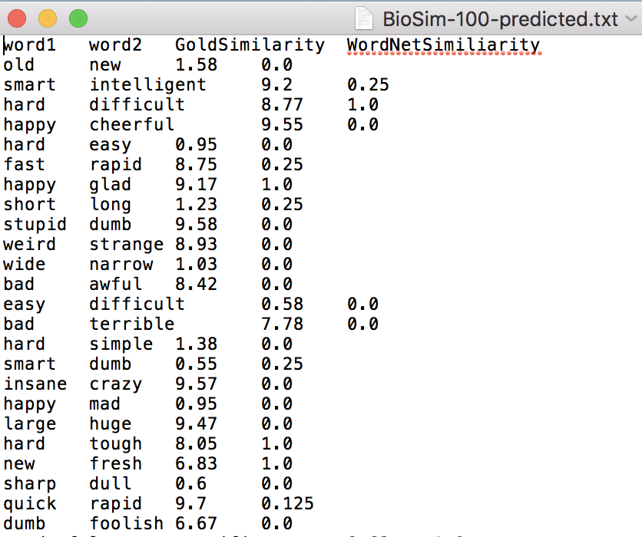

in task 1. we are going to use the re,os.path,wordnetand product packetage.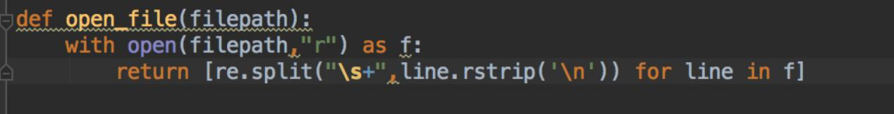

First of all we create a open file function by using open function. After we open the file we add the add the element to the array in order.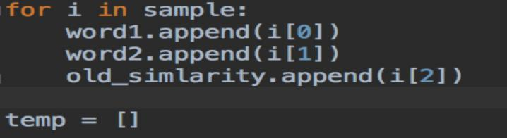

The next step is going to compare the similarity of the two words.

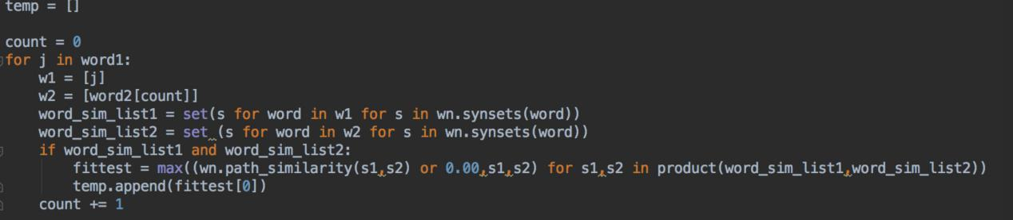

We are going to use the Path_similarity function to compare the similarity of two words. And we also use the set function to reduce the duplicate word. If there are no root of two words we define the similarity between two words is 0.00.

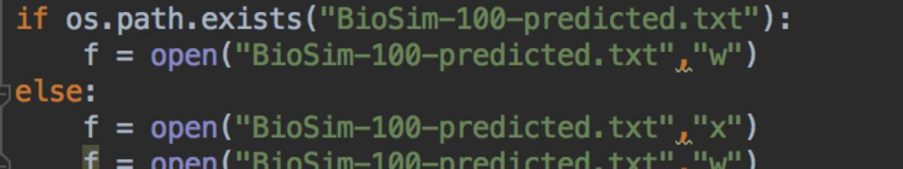

We create a file named “Bioxim-100-predicted.txt” to load the data we generate in the last function.

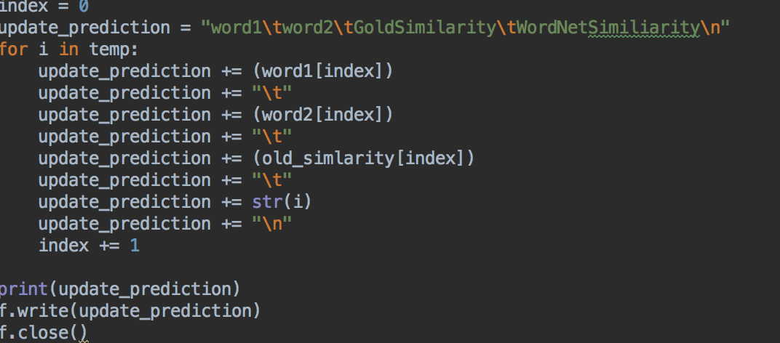

After create the file,we need to upload the data into this file. “word1” is the left-side word and “word2” is the right-side word. And “i” is the wordnet similarity. When we finish the string, we write to the file.

**Q4.Task 2**

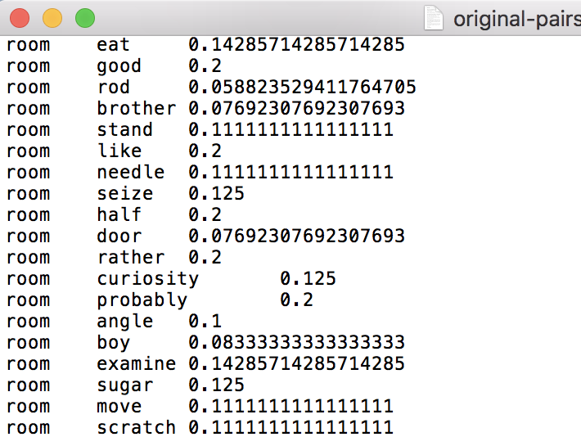

In task 2, we are going to use the word_tokenize, wordnet,stopwords and WordNetLemmatizer packages.

First of all, we need to clear the punctuation，remove the stopwords and remove the duplicated words.

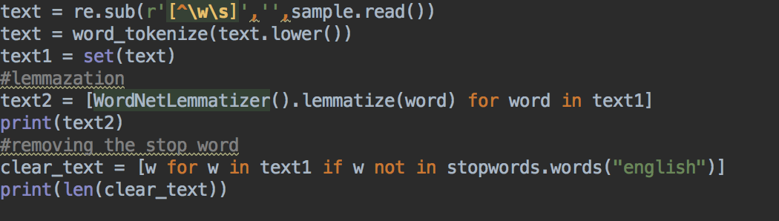

After we clean the data, we use two loops to compare the similarity between the words by using Path_similarity

function.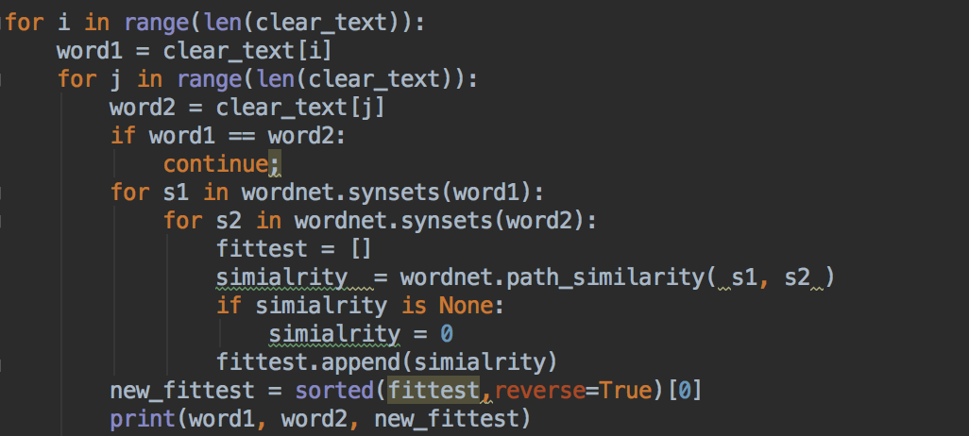

We need to create a file named ‘original-pairs.txt ’ that load the data from the last function.

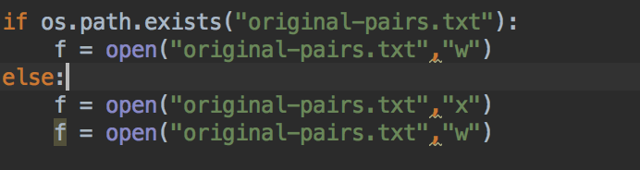

After we generate the file. We create the string and add to the document.

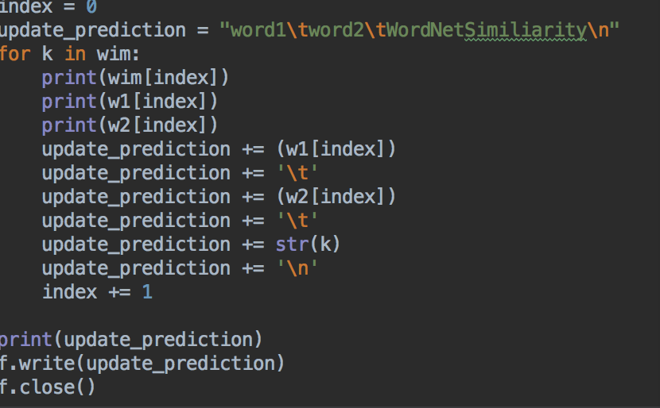

**Q4 task 3**

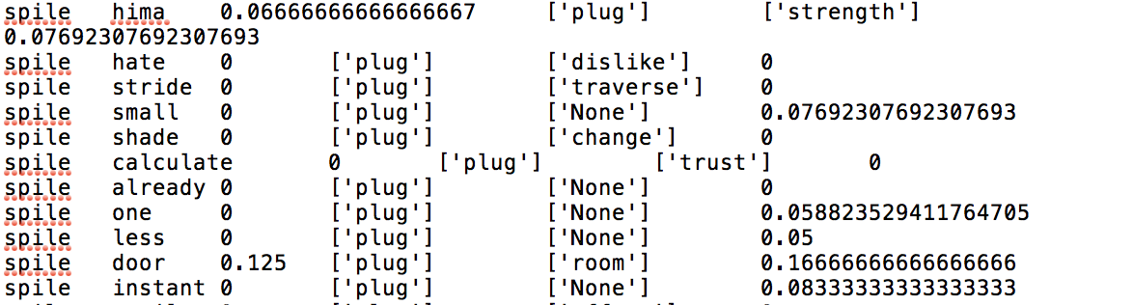

First of all, we need to get the lower letter, lemmazation, remove the punctuation and the stopwords**.**

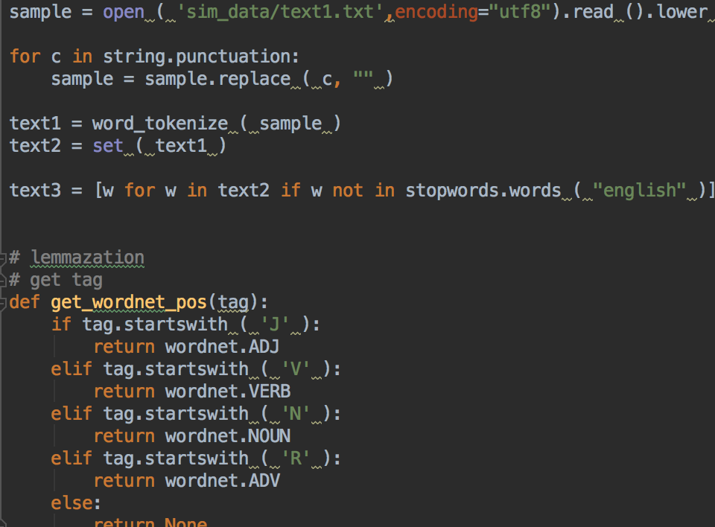

Next we use four loops to compare the similarity, we abstract the left word and right word in the first two loops. Then we get the hypwernyms of left and right word in the next two loops. Then we use the Path_similarity to compute the similarity

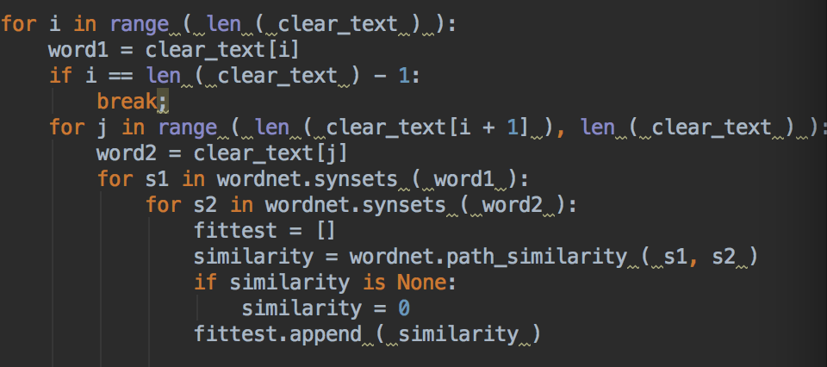

If the hypernyms of left and right words is None, we need to exchange to the zero.

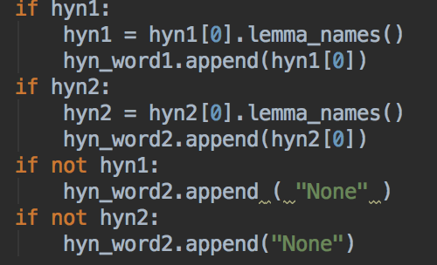

After we generate the data, we need to create the document to load the data and the formatting is UTF-8.

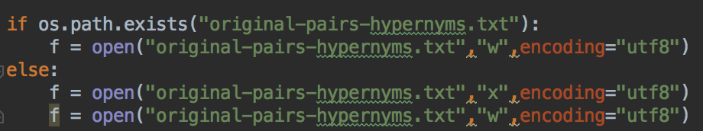

Then we create the string to meet the request and write into the file.

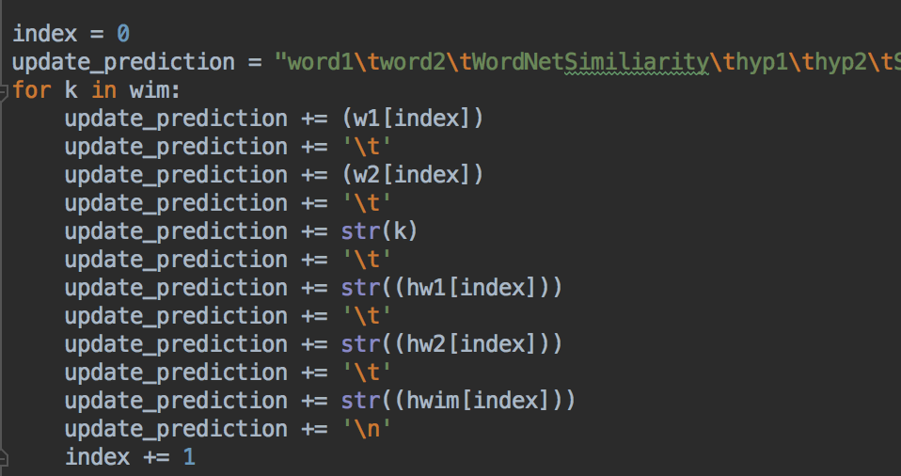

**Q4 task 4**

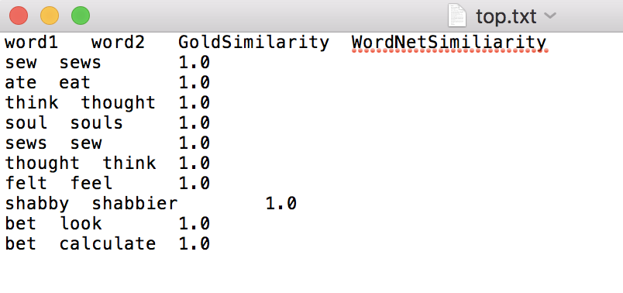

**In this task,we use the re and os.path packages. First of all we open the file we generated in the task2 by using our own open_file function**

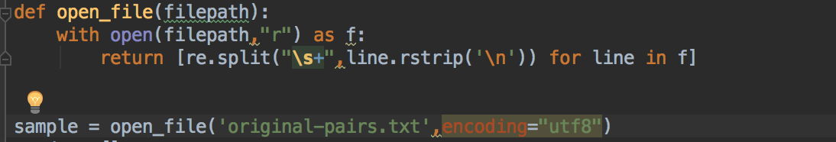

In this case we are going to use the dictionary function and set the similarity as the index of the dictionary. As the question asked us, we need to get the top 10 similarity

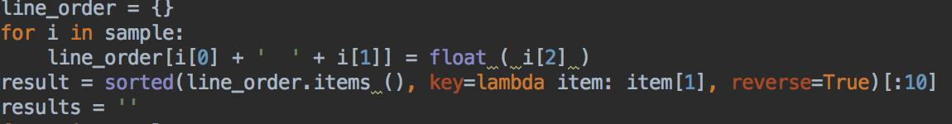

Then we create the file and upload the data we generate in the last function.

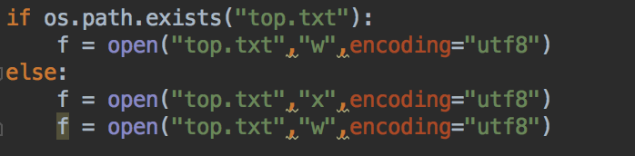

After we finished the String, we add to the documents.

